Deploying Docker Image to Azure App Service (Using ACR)
_______________________________________________________________
Step 1: Open Docker Desktop
- Launch Docker Desktop on your local machine.
- Ensure Docker Engine is running properly before proceeding.

Step 2: Build the Docker Image
Action: Create a Docker image locally from your project.
Instructions:
- Open a terminal in your project directory.
- Run the command:
docker-compose up –build
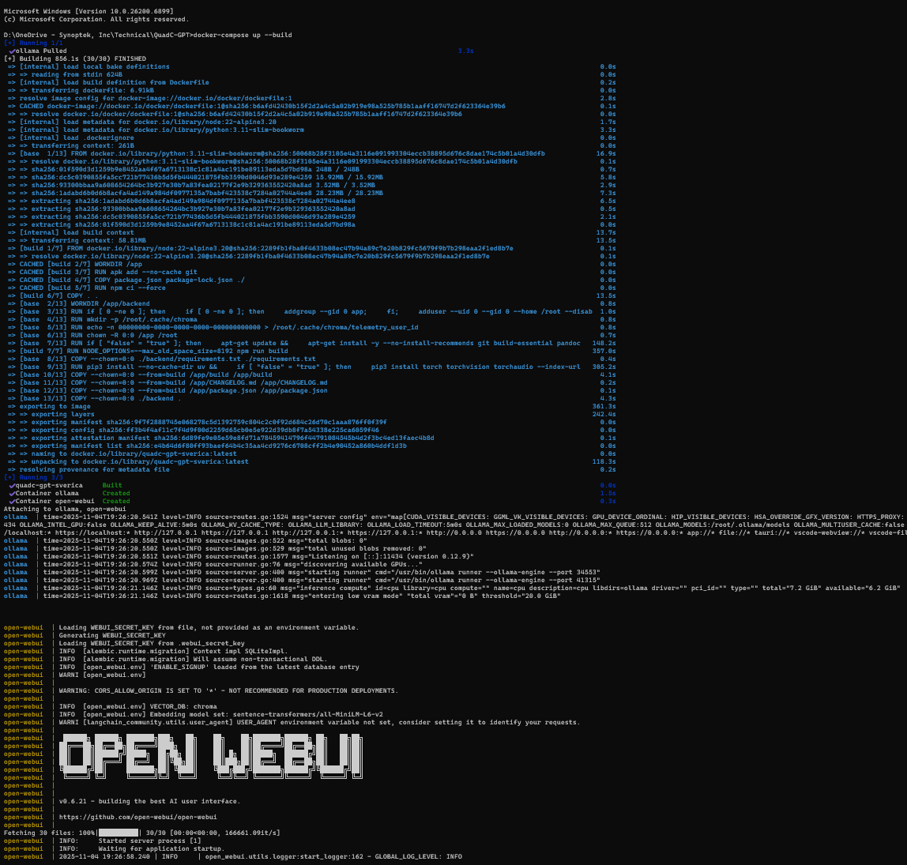
This will:
  - Build the image (e.g., open-webui)
  - Start the container automatically.
- Once build is complete, stop the process using:
  - Ctrl + C
or
  - Run the command:
docker-compose down
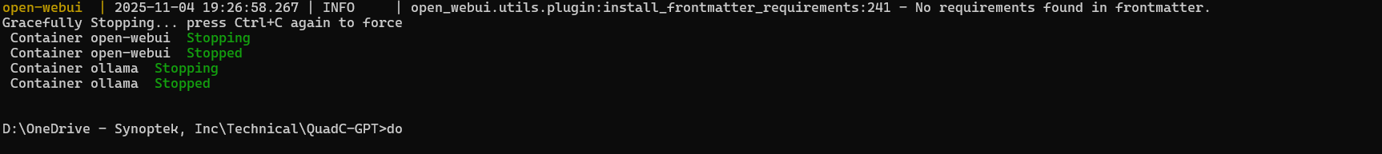
Result:
Your Docker image is now built and stored locally.
You can verify it in Docker Desktop → Images tab.
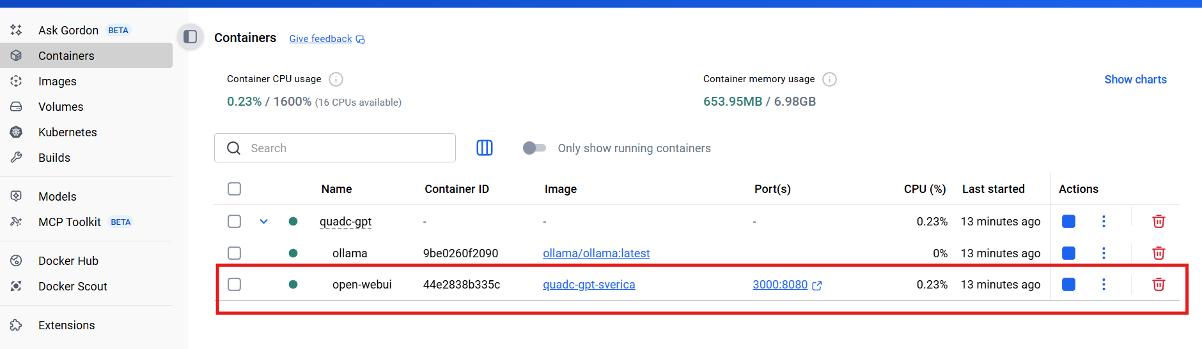

Step 3: Verify Docker Image
Action: Confirm that the image was built successfully.
Instructions:
- Run:
docker image ls
or
docker images
- Check that your image (e.g., open-webui or quadc-gpt-sverica) appears in the list.
Result:
Image creation is confirmed.
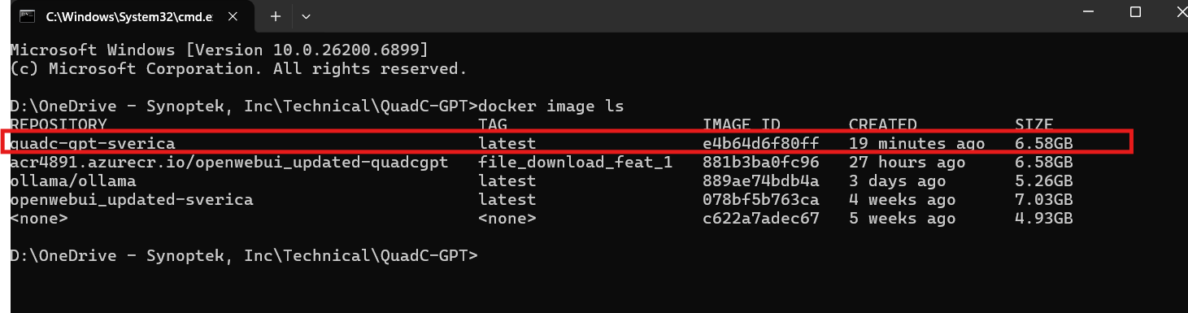

Step 4: Tag Docker Image for Azure Container Registry (ACR)
Action: Tag the local image with your ACR login server.
Syntax:
docker tag <imagename>:<tag> <registryname>/<imagename>:<newtag>
Example:
docker tag quadc-gpt-sverica:latest acr4891.azurecr.io/openwebui_updated-quadcgpt:file_download_feat_v2
Result:
The image is now tagged for your ACR (acr4891.azurecr.io).

Step 5: Verify Tagged Image
Action: Confirm that the tagged image exists locally.
Command:
docker images
Result:
You’ll see the new tagged image in the output list.
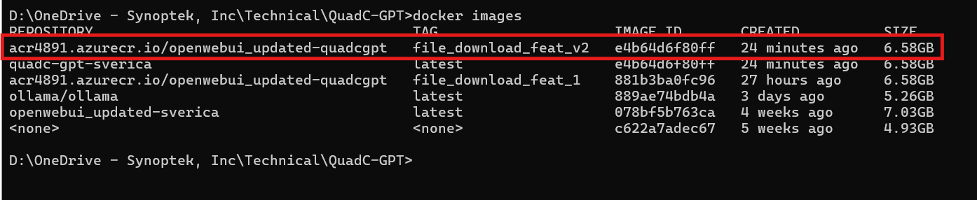

Step 6: Login to Azure Container Registry
Action: Authenticate Docker with your ACR.
Command:
docker login acr4891.azurecr.io
If prompted:
- Username: Your registry name (e.g., acr4891)
- Password: Retrieve from the Azure Portal:
To get the password:
- Go to Azure Portal
- Search for Container Registry
- Select your registry (e.g., acr4891)
- Navigate to Settings → Access keys
- Copy one of the passwords (Key1 or Key2)
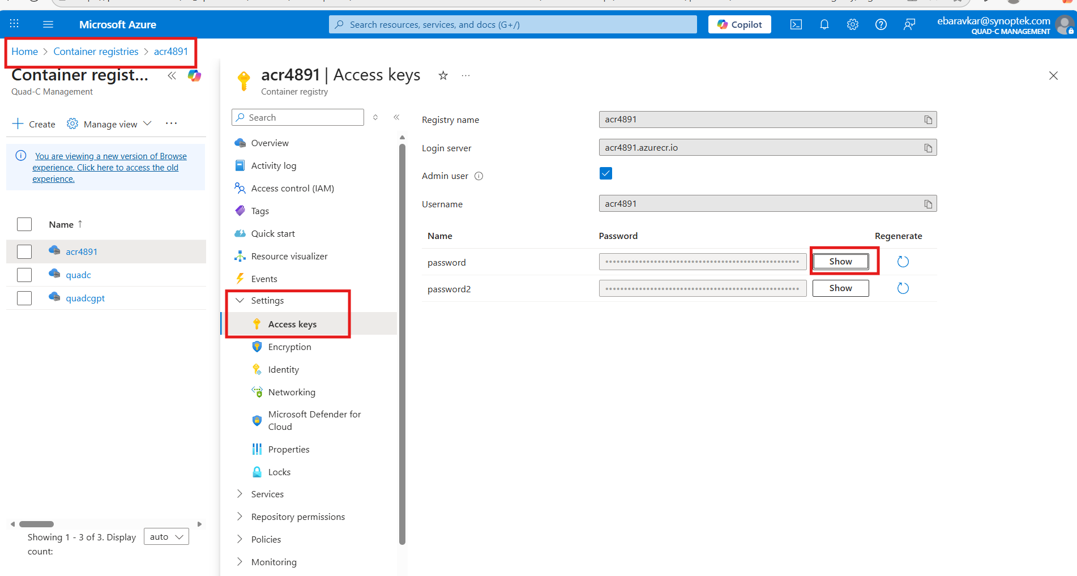

💡 If you’ve already logged in earlier, Docker will automatically use the saved credentials.
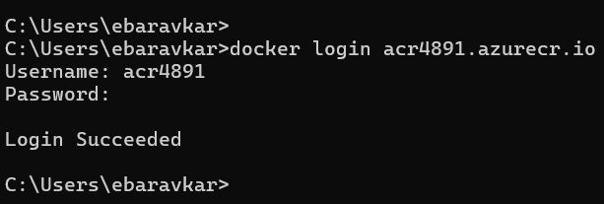
Step 7: Push Image to ACR
Syntax:
docker push <registryname>/<imagename>:<tagname>
Example Command:
docker push acr4891.azurecr.io/openwebui_updated-quadcgpt:file_download_feat_v2
Result:
Your image will be uploaded to Azure Container Registry successfully.
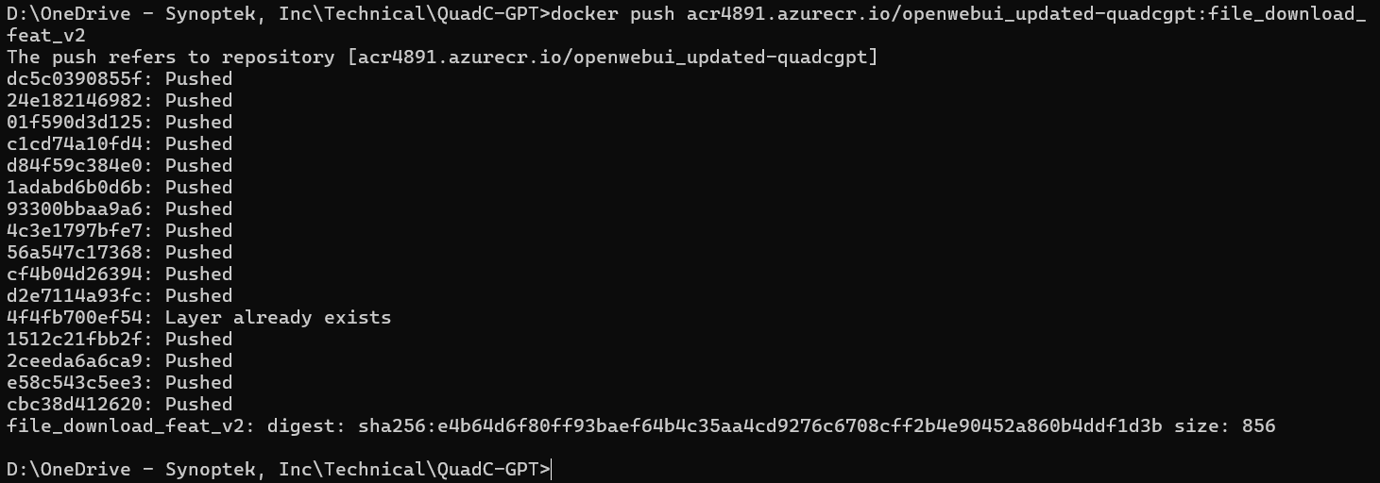

Step 8: Deploy Image on Azure App Service
Now that the image is in ACR, we’ll deploy it to Azure App Service.
Scenario:
We already have:
- Development (dev) environment
- Production (prod) environment
For testing, we’ll deploy to the dev environment.

Instructions:
1. Open Azure Portal
- Go to https://portal.azure.com
- Search for App Services
- Open the desired App Service environment (e.g., quadcgpt-dev)
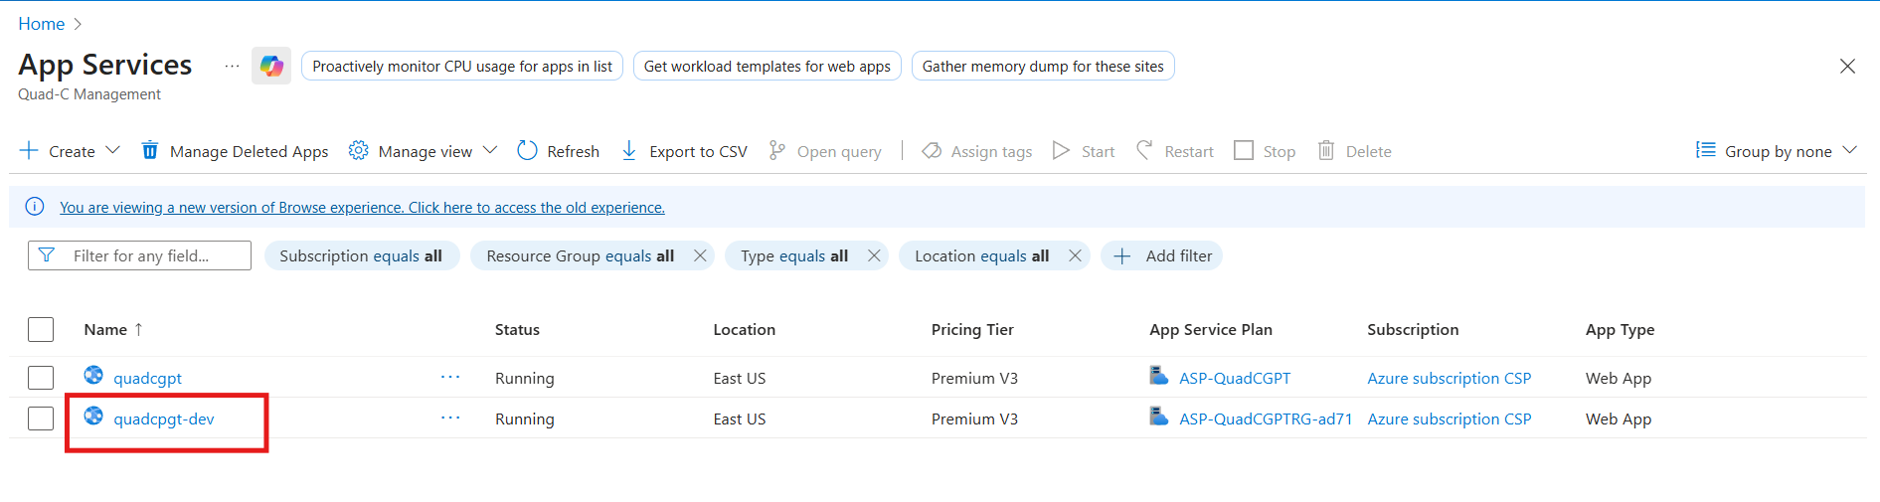
2. Navigate to Deployment Settings
- Go to:
quadcgpt-dev → Deployment → Deployment Center → Containers
- Select your main container and click Edit
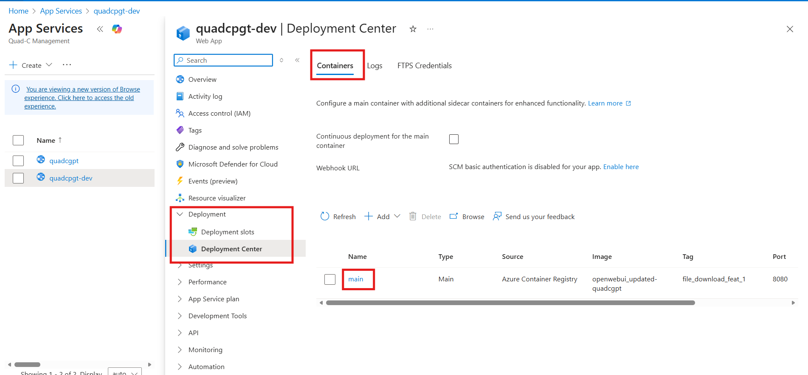

3. Configure Container Settings
In the Edit Container window, choose the following options:
Setting | Value
Image Source | Azure Container Registry
Subscription | Your subscription
Registry | Select your ACR (e.g., acr4891)
Authentication | Admin Credentials
Image Tag | Select your pushed image tag (e.g., file_download_feat_v2)
Port | 8080

Then click Apply to save the container settings.
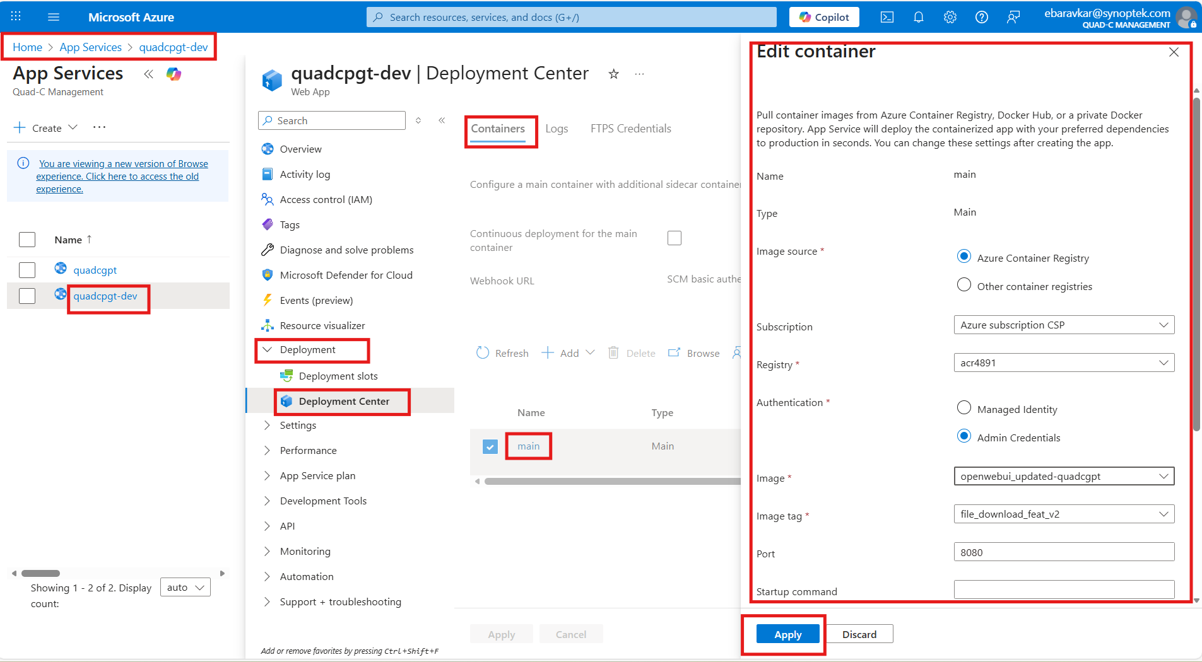

Step 9: Verify Deployment
- After applying settings, go to the Overview tab of your App Service.
- Click the Default domain URL to open your web app in the browser.
- The application will launch — for the first time, it may ask for authentication.
- Sign in using your credentials.
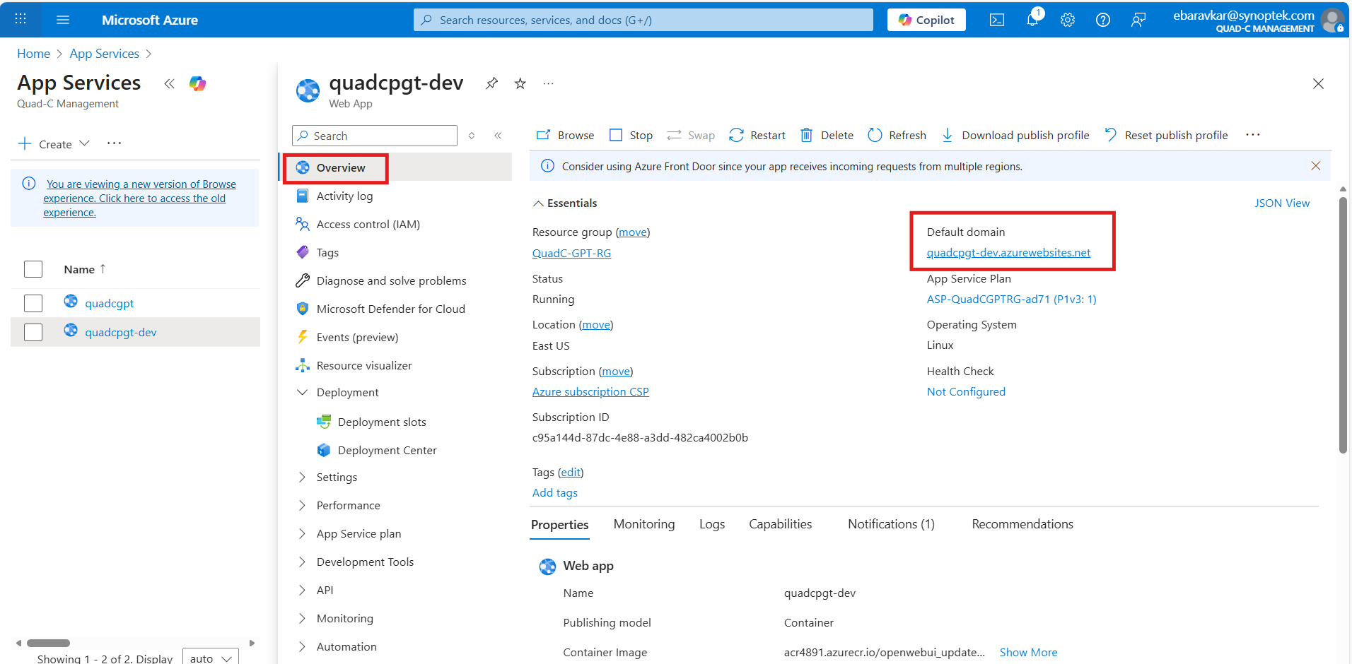

Result:
Your Docker image is successfully deployed and running on Azure App Service.
🎉 You’re now logged in and your application is live!

